匡智慈善跑樓梯大賽 2025 (2025年10月18日，星期六)
Hong Chi Climbathon 2025 (18 Oct 2025, Saturday)

轉換隊員或位置更新表格
Team Members & Positions Amendment Form

請於2025年 9月 18日 (星期四) 或之前以電郵(cfr@hongchi.org.hk)交回本表格
Please return this form on or before 18September 2025 (Thu) by email (cfr@hongchi.org.hk)
公司/機構/團體名稱 Name of Company/ Organization: __________________________________________
隊伍名稱Team Name: ____________________________________________________________________
聯絡人Contact Person：(先生Mr / 女士Ms) __________________________________________________
聯絡電話 Contact No.：______________________ 電郵Email：__________________________________
參賽組別Race Categories：
75層接力賽 75/Floor Relay ◻公開組Open ◻紀律部隊Disciplined Services
75層共融接力賽 75/Floor Integration Relay ◻公開組Open ◻非牟利機構NGO
29層接力賽 29/Floor Relay ◻公開組Open
29層共融接力賽 29/Floor Integration Relay ◻公開組Open ◻非牟利機構NGO
7層親子體驗跑 7/Floor Family Run ◻

轉換隊員或位置 Amend Team Member or Runner Position：

位置  Position | 隊員姓名 中文及英文  Name of Team Member | 新隊員  New Team Member  ✓ ¹ | 隊長  Team Leader  ✓ ² | 性別  Sex | 年齡組別  Age Group |  | 匡智學員/學生  Hong Chi  Trainee/Student  (✓ / x) | 活動T恤尺碼  Event Tee Size³
 |  |  |  |  | 14-17 | 18或以上  18 or above | 匡智學員/學生  Hong Chi  Trainee/Student  (✓ / x) | 活動T恤尺碼  Event Tee Size³
第一棒Leg #1 |  |  |  |  | ◻ | ◻
第二棒Leg #2 |  |  |  |  | ◻ | ◻
第三棒Leg #3 |  |  |  |  | ◻ | ◻
第四棒Leg #4 |  |  |  |  | ◻ | ◻
第五棒Leg #5  只適用於75層接力賽  For 75/Floor Relay Only |  |  |  |  | ◻ | ◻

¹ 接力隊伍必須於隊員中選出一名隊長，作為主要聯絡人。Each relay team must assign one team member as the leader to be the primary contact person.

² T恤尺碼- 胸寬(厘米) x衫長(厘米) Tee Size- Chest (cm) x Length (cm): S-96x66, M-100x67.5, L-104x69, XL-108x70.5, XXL-112x72, , XXXL- 118 x 74。各尺碼數量有限，先到先得。如所選尺碼已派完，將以另一尺碼代替。Another size will be given if the requested size is out of stock.
如不需要活動T恤，請漏空此格。Please leave blank if you don’t want to have the event tee.

每次更改隊員資料或位置需額外向「匡智會」捐款港幣300元正。
Each amendment of team member information or runner position would incur an additional HK$300 donation to "Hong Chi Association".

如有查詢，請致電2661 0709或發WhatsApp訊息至9311 9651。
For inquiries, please call 2661 0709 or send WhatsApp message to 9311 9651.
付款方法 Payment Methods:
❑ 劃線支票By Cheque (支票號碼Cheque No. __________________)
祈付「匡智會」，並於背面註明「匡智跑樓梯大賽2025」。
Payable to “Hong Chi Association” and write on the back “Hong Chi Climbathon 2025”.
❑ 透過銀行 / 自動櫃員機 via Bank / ATM machine
➢滙豐銀行戶口 HSBC account: 500-118351-009 ➢中國銀行戶口 BOC account: 012-595-10202107
請提供轉賬收據副本作證明，並註明「匡智跑樓梯大賽2025」。
Please provide transaction receipt copy and state “Hong Chi Climbathon 2025”.
❑ 信用卡By Credit Card: ◻ AMEX ◻ Master ◻ Visa
持卡人姓名 Name of Cardholder __________________ 信用卡號碼 Card Number _____________________
有效日期至 Expiry Date ________________ 持卡人簽署 Cardholder’s Signature ______________________

❑ 電子支付 By Electronic Payment System
請提供成功轉賬的截圖以作證明，並註明「匡智跑樓梯大賽2025」。
Please provide screenshot of successful payment information to us and state “Hong Chi Climbathon 2025”.
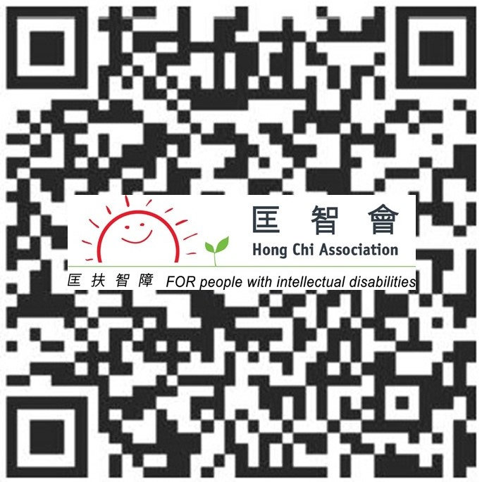 |   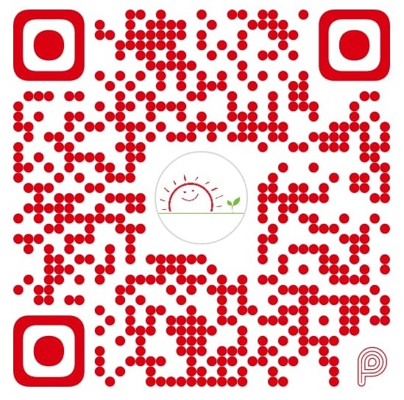
支付寶 Alipay
PayMe
轉數快 FPS

